Practicum Final Exam – Even Semester Year 2021/2022
Subject |  |  | COMP6579 – Big Data Processing |  |  | 
Class | : | BC01 / BD01 |  | Start Date | : 17 June 2021
Lecturer | : | D6414 - Kristien Margi Suryaningrum, S.Kom., M.Cs. |  | Start Time | : 15:20
Lecturer | : |  |  | End Date | : 17 June 2021
Lecturer | : |  |  | End Time | : 17:20

PERATURAN UJIAN:
Exam Regulations:
- Mahasiswa tidak diperbolehkan berdiskusi dan/atau bekerja sama dengan peserta ujian lainnya
Student is not allowed to discuss and/or work together with other exam participants
- Mahasiswa tidak diperbolehkan untuk membuka dan menyalin dari BUKU atau CATATAN, VIDEO dari pengajar (recording kelas, VBL, Youtube, dsb) dan REFERENSI lainnya
Student isn't allowed to open and copy from any resources such as notes, videos (class recording, VBL, Youtube, etc) and other references
- Mahasiswa tidak diperbolehkan membuka dan menyalin jawaban dari internet (google, stackoverflow, dsb)
Student isn't allowed to open and copy answer from the internet (google, stackoverflow, etc)
- Asisten BERHAK memberi nilai 0 (NOL) bagi peserta ujian yang melakukan segala bentuk kecurangan
Assistant is able to give 0 (ZERO) score for exam participant who does any cheating actions
- Kumpulkan jawaban tepat pada waktunya, apabila terlambat mengumpulkan maka jawaban tidak akan dikoreksi dan nilai mahasiswa adalah 0
Submit the answer on time, if not, then the answer will not be checked, and the students will receive 0 (ZERO)
- Bila Anda tidak membaca peraturan ini, maka Anda dianggap telah membaca dan menyetujuinya
If you have missed to read these regulations, so you are considered to have read and agreed on it



SOFTWARE YANG DIGUNAKAN:
Software will be used:
- Jupyter Notebook
- VM Cloudera
- VMWare Workstation 15

FILE YANG DIKUMPULKAN:
File must be collected:
- IPYNB

PERHATIAN!
Attention!
- Bagi yang mengerjakan tidak sesuai dengan soal, maka akan diberikan nilai NOL (0)
For those who do not work in accordance with the exam case will be marked as ZERO (0)
- Bagi yang mengerjakan tidak sesuai dengan software dan versi yang telah ditetapkan, maka akan tetap dikoreksi dengan software dan versi yang telah ditetapkan
For those who do not work in accordance with the software and specific version will be corrected by the predefined software and version
- Kompres semua jawaban yang akan diunggah. Pastikan format pengumpulan nama file dan ekstensi sesuai dengan format berikut: [NIM]-[NAMA].zip
Compress all file that will be uploaded. Make sure the format for collecting file name and extension according to the following format: [NIM]-[NAME].zip

Soal
Case
CakeT Online Shop
CakeT Online Shop is an online shop which is currently being popular in India. Since the transactions are on high demands, you are hired to make some analysis on the data they have. Below is the Caket Online Shop ERD that you are to analyze:

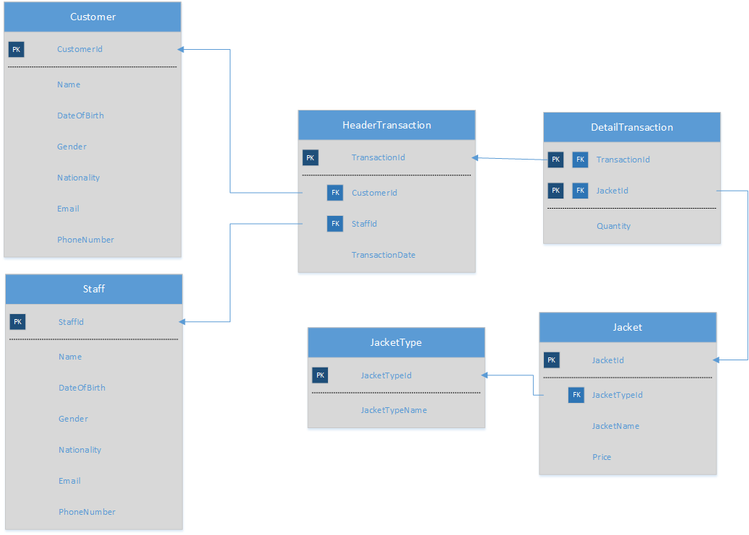
Figure 1. Caket Online Shop ERD

Below is the task you must do to analyze the data:
- Load Data from CSV to Spark
Using SparkSession, read the following files (“Customer.csv”, “DetailTransaction.csv”, “HeaderTransaction.csv”, “Jacket.csv”, “JacketType.csv”, “Staff.csv”).
- Query Analysis and Visualization
You are asked to gain some sales insight about the data. Below are some statements you need to answer. Use SparkSQL to answer the question and pyplot package to visualize the answer.
- Show the percentage of jacket type sold in which the jacket price must be above 500000 using pie plot.
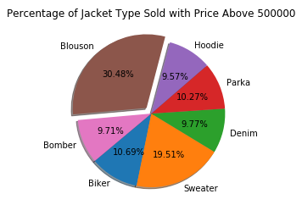
Figure 2. Most Sold Jacket Type with Price Above 5000 Figure
- Show the number of gross income per year between 2016 until 2019 using line plot.
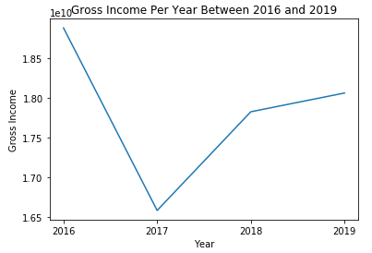
Figure 3. Gross Income Per Year Between 2016 and 2019 Figure
- Show the frequency of the order rate for every month in 2019 using bar plot. The order rate in a certain month is determined based on the following condition:
Order Rate | Jackets Ordered per Month
High | > 4000
Medium | 2501 - 4000
Low | <= 2500

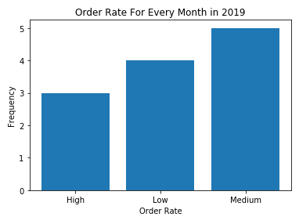
Figure 4. Order Rate for Every Month in 2019 Figure

Diabec
Diabec is a health organization that checks whether a person has diabetes or not. They also want to prove myths about diabetes, because some people argue that people got diabetic because they eat lots of sugar, while some people argue the other way around. Due to that, they decided that they want to make a clustering model that will have 2 cluster, people with diabetes cluster and people without diabetes cluster. You will be given Train.csv and Test.csv and here is the description of the columns:

Column Name | Description
Glucose | The persons’ plasma glucose concentration in the  glucose tolerance test
DiabetesPedigreeFunction | A function that shows likelihood of diabetes that are  based on genetic of family history.
Insulin | 2-Hour serum insulin (mu U/ml).  Insulin is a hormone made by the pancreas that allows your body to use sugar (glucose) from carbohydrates in the food that you eat for energy or to store glucose for future use. The function is to unlock cells so glucose  can get inside.
TotalCholestrolLevel | Total Cholesterol Level milligrams per deciliter.
LowerBackPain | Whether the person experience back pain or not  (Yes, No)
SugarInTake/day | The level of sugar intake per day (High, Medium, Low)
Figure 5. Train.csv

Column Name | Description
Glucose | The persons’ plasma glucose concentration in the  glucose tolerance test
DiabetesPedigreeFunction | A function that shows likelihood of diabetes that are  based on genetic of family history.
Insulin | 2-Hour serum insulin (mu U/ml).  Insulin is a hormone made by the pancreas that allows your body to use sugar (glucose) from carbohydrates in the food that you eat for energy or to store glucose for future use. The function is to unlock cells so glucose  can get inside.
TotalCholestrolLevel | Total Cholesterol Level milligrams per deciliter.
LowerBackPain | Whether the person experience back pain or not  (Yes, No)
SugarInTake/day | The level of sugar intake per day (High, Medium, Low)
Outcome | Whether the person has diabetes or not (Yes, No)
Figure 6. Test.csv
Below are the steps you are required to do to generate the model:
- Load Data
Given the file “Train.csv” and “Test.csv”, you are asked to load the data using SparkSession.
- Select Features
After you load the data, you need to select important features that will be used for training. Pick three important features.
- Data Preprocessing
In this step, please remove any missing values in the data.
- Transform Data
In this step, transform the raw data so that it is suitable for training. For example, recode the ‘SugarInTake/day’ column value to be either 0, 1, or 2.
- Normalization
After data preprocessing, you are required to normalize the data. Use the StandardScaler
package to normalize the data.
- Generate Model
Next, you are required to generate a model from the data. Use the KMeans package to generate the model into 2 cluster.
- Visualization
After the model is generated, you can visualize the model using the pyplot package. Don’t forget to add x-label, y-label, and title for your plot.
- Model Testing and Evaluation
Then, you can test the model to check predict whether the person will be in diabetic cluster or in the non-diabetic cluster. Print the accuracy of your model and get the model with minimum accuracy 90% or higher.

Good Luck 😊

